**Excel Assignment - 9**

**1. What are the different margins options and do we adjust the margins of the excel worksheet?**

**Normal:** the normal margin is the default value set for excel sheet and page. It uses the standard top, bottom, left, and right margin of 3/4 inch, where ¼ inch separates the header and footer from the top and bottom margins, respectively.

**Wide:** It uses the standard top, bottom, left, and right margin of 1 inch, where ½ inch separates the header and footer from the top and bottom margins, respectively.

**Narrow:** It uses the standard top and bottom margin of ¾ inch, left and right margins 1/4 inch, where 0.3 inch separates the header and footer from the top and bottom margins, respectively.

**Custom:** we can specify desired margins for header and footer and center the content of our sheet vertically and horizontally.

**2. Set a background for your table created.**

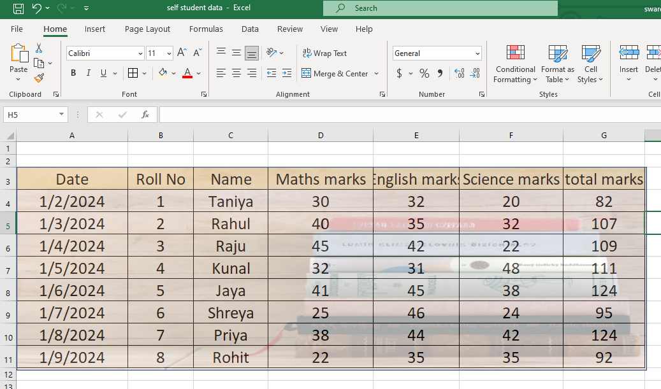

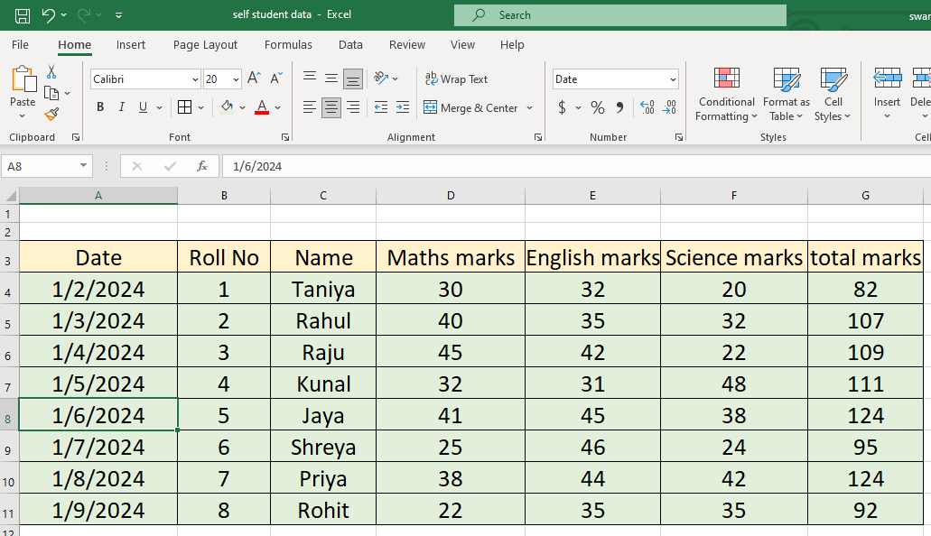

**3. What is freeze panes and why do we use freeze panes? Give examples.**

Freeze panes is a feature in excel where the user can freeze a row and a column and can scroll through rest of the data.

* It enhances your productivity when the data is huge.
* It allows you to keep important information visible, even when you scroll down.
* It makes the task easier to analysis or to search certain information.

Example:

* To freeze the row, select the row you want to freeze, click on view tab.

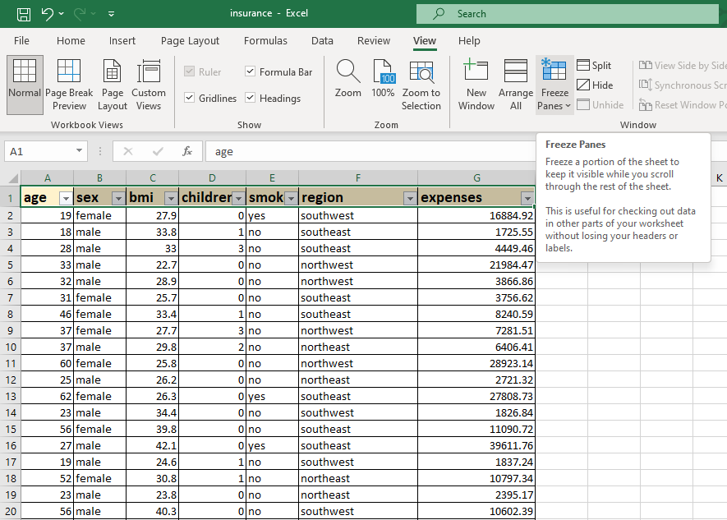

* Click on freeze panes dropdown and select freeze top row option.

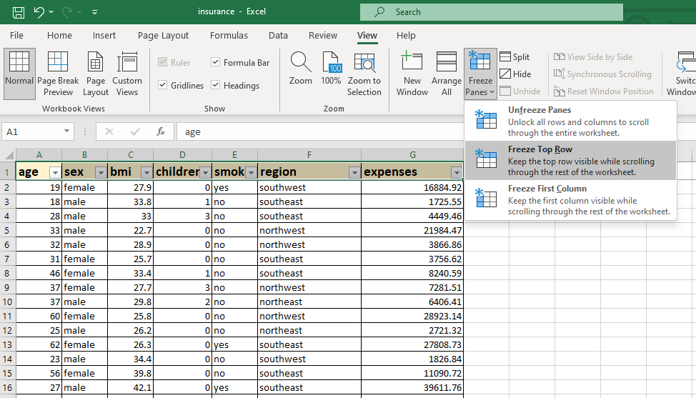

* The first row of the worksheet has been frozen and you can see the dark grey line been placed below the first row. As you can see in the picture the first row is frozen n we can scroll rest of the data.

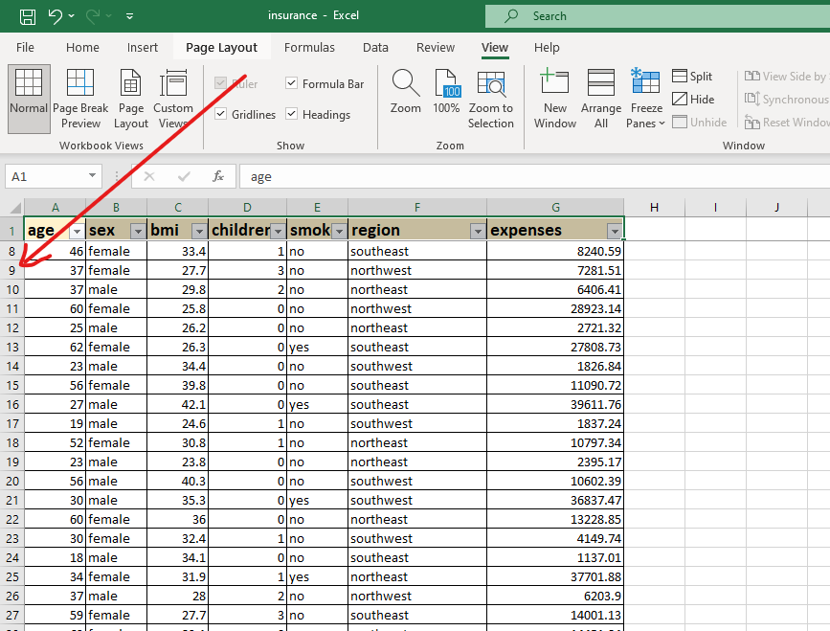

**4. What are the different features available within the Freeze Panes command?**

* **Freeze panes:** by using this command user can freeze selected row and column together. If you want to see row 1 and column A all the time, we have these reference point. In this case we select B2 as reference point and click on freeze panes. When we scroll up the first line will be frozen and when we scroll right the first column will be frozen.
* **Freeze top row:** in this command we can freeze a certain row. Select the rows that you want to freeze and click freeze top row the selected top rows will be freeze.
* **Freeze first column:** in this command you can freeze first column of a table. Select the column you want to freeze and click freeze first column
* **Unfreeze panes:** once you freeze certain row and column you will get the option of unfreeze panes. If you want to unfreeze the panel you can click on unfreeze panes.

**5. Explain what the different sheet options present in excel are and what they do?**

* **Ribbon sheet option**: sheet options are present on ribbon and be accessed by going to page layout >sheet options. It has 4 options 2 for gridlines and 2 for heading. Gridline’s view allows user to show / hide gridline within the active sheet. Gridline’s print allows user to show or hide the on an excel document that will be printed on paper. Same for heading.
* **Right click sheet option:** when you select the sheet and right click context menu is displayed for selected elements. It displays many options which are related sheet, it is called as worksheet menu. The worksheet menu has options like insert, delete, rename, move or copy, view code, protect sheet tab color, hide or unhide and select all sheets.